**Exp-10 Role Based Login with Redux (alternative to sessionStorage)**

Why Redux (React Context) Works Better than sessionStorage

✅ Reactivity: When role changes, components update automatically.

✅ Security: Data isn't stored in the browser, making it more secure than sessionStorage.

✅ No Page Refresh Needed: React Context ensures data remains available across all pages.

--------------------------------------------------------------------

Understanding Redux Basics:

Redux is a state management library that helps manage global state in React applications.

It follows a unidirectional data flow and consists of three main parts:

Store → The centralized state of your application.

Actions → Plain JavaScript objects describing what should change in the state.

Reducers → Functions that determine how the state should change based on actions.

-----------------------------------------------------------------------

Redux Flow in our Experiment

Since you’re implementing authentication using Redux, here’s how Redux works in your case:

User logs in (Signin.jsx) → Dispatches an action to update the Redux state.

Redux Store updates (store.js) → Stores role and username in global state.

Navigation (Show.jsx) → Uses Redux state instead of sessionStorage to determine access.

**Separation of Concerns**:

* .jsx is generally used for components (UI-related files).
* .js is preferred for Redux logic, as it does not contain JSX code.

**To create a project:** $Npm create vite@latest (Project Name: Exp10)

**Installations:**

npm install react-router-dom@6

npm install redux react-redux @reduxjs/toolkit

npm install @mui/material @emotion/react @emotion/styled @mui/icons-material

npm install axios

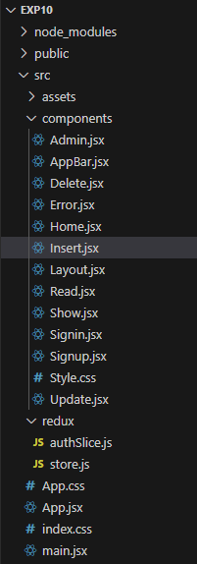

**index.html**

-------------------------------------------------------

<!doctype html>

<html lang="en">

<head>

<meta charset="UTF-8" />

<link rel="icon" type="image/svg+xml" href="/vite.svg" />

<meta name="viewport" content="width=device-width, initial-scale=1.0" />

<link rel="stylesheet" href="https://cdnjs.cloudflare.com/ajax/libs/font-awesome/4.7.0/css/font-awesome.min.css">

<link rel="stylesheet" href="https://maxcdn.bootstrapcdn.com/bootstrap/3.4.1/css/bootstrap.min.css">

<script src="https://ajax.googleapis.com/ajax/libs/jquery/3.7.1/jquery.min.js"></script>

<script src="https://maxcdn.bootstrapcdn.com/bootstrap/3.4.1/js/bootstrap.min.js"></script>

<title>Vite + React</title>

</head>

<body>

<div id="root"></div>

<script type="module" src="/src/main.jsx"></script>

</body>

</html>

--------------------------------------------------------------------------------------

**Main.jsx**

import { createRoot } from 'react-dom/client'

import { BrowserRouter } from "react-router-dom";

import { Provider } from "react-redux";

import { store } from "./redux/store";

import Show from "./components/Show.jsx";

import './index.css'

createRoot(document.getElementById("root")).render(

  //Provider tag here makes the Redux store available to all components.

  <Provider store={store}>

    <BrowserRouter>

      <Show />

    </BrowserRouter>

  </Provider>

);

**Show.jsx**

import React from "react";

import { Routes, Route, Navigate } from "react-router-dom";

import { useSelector } from "react-redux";

import Signin from "./Signin";

import Signup from "./Signup";

import Home from "./Home";

import Admin from "./Admin";

import Layout from "./Layout";

import Error from "./Error";

export default function Show() {

  //Uses useSelector() to check role from Redux.

  const role = useSelector((state) => state.auth.role);

  return (

    <Routes>

      <Route path="/" element={<Layout />}>

        <Route index element={<Home />} />

        <Route path="signin" element={<Signin />} />

        <Route path="signup" element={<Signup />} />

        <Route path="error" element={<Error />} />

        <Route path="home" element={role === 1 || role === 2 ? <Home /> : <Navigate to="/error" />} />

        <Route path="admin" element={role === 1 ? <Admin /> : <Navigate to="/error" />} />

      </Route>

    </Routes>

  );

}

**AppBar.jsx**

import * as React from "react";

import AppBar from "@mui/material/AppBar";

import Box from "@mui/material/Box";

import Toolbar from "@mui/material/Toolbar";

import IconButton from "@mui/material/IconButton";

import Typography from "@mui/material/Typography";

import Menu from "@mui/material/Menu";

import MenuIcon from "@mui/icons-material/Menu";

import Container from "@mui/material/Container";

import Button from "@mui/material/Button";

import MenuItem from "@mui/material/MenuItem";

import { useNavigate } from "react-router-dom";

import { useSelector, useDispatch } from "react-redux";

import { logout } from "../redux/authSlice";

const pages = ["Signin", "Signup", "Home", "Admin"];

function ResponsiveAppBar() {

  const [anchorElNav, setAnchorElNav] = React.useState(null);

  const navigate = useNavigate();

  const dispatch = useDispatch();

  const username = useSelector((state) => state.auth.username);

  const role = useSelector((state) => state.auth.role);

  const handleOpenNavMenu = (event) => {

    setAnchorElNav(event.currentTarget);

  };

  const handleCloseNavMenu = () => {

    setAnchorElNav(null);

  };

  return (

    <AppBar position="static">

      <Container maxWidth="xl">

        <Toolbar disableGutters>

          <Typography variant="h6" noWrap component="div" sx={{ flexGrow: 1 }}>

            LOGO

          </Typography>

          <Box sx={{ display: { xs: "none", md: "flex" } }}>

            {pages.map((page) => (

              <Button

                key={page}

                onClick={() => {

                  navigate(`/${page.toLowerCase()}`);

                  handleCloseNavMenu();

                }}

                sx={{ color: "white" }}

              >

                {page}

              </Button>

            ))}

          </Box>

          {username ? (

            <Button

              onClick={() => {

                dispatch(logout());

                navigate("/signin");

              }}

              sx={{ color: "white", marginLeft: 2 }}

            >

              Logout ({username})

            </Button>

          ) : null}

          <Box sx={{ display: { xs: "flex", md: "none" } }}>

            <IconButton size="large" onClick={handleOpenNavMenu} color="inherit">

              <MenuIcon />

            </IconButton>

            <Menu anchorEl={anchorElNav} open={Boolean(anchorElNav)} onClose={handleCloseNavMenu}>

              {pages.map((page) => (

                <MenuItem key={page} onClick={() => navigate(`/${page.toLowerCase()}`)}>

                  {page}

                </MenuItem>

              ))}

            </Menu>

          </Box>

        </Toolbar>

      </Container>

    </AppBar>

  );

}

export default ResponsiveAppBar;

**Signup.jsx**

import React from 'react';

import './style.css';

import axios from 'axios';

export default function Signup() {

    function InsertUser() {

        var un = document.getElementsByName("un")[0].value;

        var pw = document.getElementsByName("pw")[0].value;

        var role = document.getElementsByName("role")[0].value;

        axios.post("http://localhost:8080/user", {

            "un": un,

            "pw": pw,

            "role": role

        }).then((res) => {

            alert(res.data);

        });

    }

    return (

        <div >

            <center>

                <div className="signin-box">

                    <table>

                        <tr>

                            <td colSpan={2}>SignUp Page</td>

                        </tr>

                        <tr>

                            <td>UserName:</td>

                            <td><input type="text" name="un" class="form-control"/></td>

                        </tr>

                        <tr>

                            <td>Password:</td>

                            <td><input type="password" name="pw" class="form-control"/></td>

                        </tr>

                        <tr>

                            <td>Role:</td>

                            <td>

                                <select class="form-select" name="role">

                                    <option value={1}>Admin</option>

                                    <option value={2}>User</option>

                                </select>

                            </td>

                        </tr>

                        <tr>

                            <td colSpan={2}><button onClick={InsertUser}>SignUp</button></td>

                        </tr>

                    </table>

                </div>

            </center>

        </div>

    );

}

**Signin.jsx**

import React, { useState } from "react";

import "./style.css";

import axios from "axios";

import { useDispatch } from "react-redux";

import { useNavigate } from "react-router-dom";

//import { login } from "../authSlice";

import {login} from "../redux/authSlice"

export default function Signin() {

  const dispatch = useDispatch();

  const navigate = useNavigate();

  const [username, setUsername] = useState("");

  const [password, setPassword] = useState("");

  function checkUser() {

    axios

      .post("http://localhost:8080/check", { un: username, pw: password })

      .then((res) => {

        if (res.data !== "0") {

          dispatch(login({ username, role: res.data })); // Save to Redux

          navigate(res.data == 1 ? "/admin" : "/home");

        } else {

          alert("Invalid credentials");

        }

      });

  }

  return (

    <div>

      <center>

        <div className="signin-box">

          <table>

            <tbody>

              <tr>

                <td colSpan={2}>Signin Page</td>

              </tr>

              <tr>

                <td>UserName:</td>

                <td>

                  <input

                    type="text"

                    value={username}

                    onChange={(e) => setUsername(e.target.value)}

                    className="form-control"

                  />

                </td>

              </tr>

              <tr>

                <td>Password:</td>

                <td>

                  <input

                    type="password"

                    value={password}

                    onChange={(e) => setPassword(e.target.value)}

                    className="form-control"

                  />

                </td>

              </tr>

              <tr>

                <td colSpan={2}>

                  <button onClick={checkUser}>Login</button>

                </td>

              </tr>

            </tbody>

          </table>

        </div>

      </center>

    </div>

  );

}

**store.js (/src/reducer/store.js)**

import { configureStore } from "@reduxjs/toolkit";

import authReducer from "./authSlice";

export const store = configureStore({

  reducer: {

    auth: authReducer,

  },

});

------------------------------------------------------------------------------------------------

**authSlice.js (/src/reducer/authSlice.js)**

import { createSlice } from "@reduxjs/toolkit";

const initialState = {

  username: null,

  role: 0,

};

const authSlice = createSlice({

  name: "auth",

  initialState,

  reducers: {

    login: (state, action) => {

      state.username = action.payload.username;

      state.role = action.payload.role;

    },

    logout: (state) => {

      state.username = null;

      state.role = 0;

    },

  },

});

export const { login, logout } = authSlice.actions;

export default authSlice.reducer;

----------------------------------------------------------------------------------------------------------------------

**Layout.jsx**

import ResponsiveAppBar from './AppBar';

import { Outlet } from 'react-router-dom';

const Layout = () => {

  return (

    <div className="parent">

      <ResponsiveAppBar />

      <div style={{ padding: '20px' }} className="page">

        <Outlet /> {/* This will render nested routes */}

      </div>

    </div>

  );

};

export default Layout;

**Home.jsx**

import React, { useState } from 'react';

import Insert from './Insert';

import Read from './Read';

import "./style.css";

export default function Home() {

    const [activeComponent, setActiveComponent] = useState(null);

    return (

        <div>

            <h1>Home DashBoard</h1>

            <button onClick={() => setActiveComponent('insert')} className="buttonStyle">Insert</button>

            <button onClick={() => setActiveComponent('read')} className="buttonStyle">Read</button>

            <div>

                {activeComponent === 'insert' && <Insert />}

                {activeComponent === 'read' && <Read />}

            </div>

        </div>

    );

}

----------------------------------------------------------------------------------------------

**Admin.jsx**

import React, { useState } from 'react';

import Insert from './Insert';

import Read from './Read';

import Update from './Update';

import Delete from './Delete';

export default function Admin() {

    const [activeComponent, setActiveComponent] = useState(null);

    return (

        <div>

            <h1>Admin Panel</h1>

            <button onClick={() => setActiveComponent('insert')} className="buttonStyle">Insert</button>

            <button onClick={() => setActiveComponent('read')} className="buttonStyle">Read</button>

            <button onClick={() => setActiveComponent('update')} className="buttonStyle">Update</button>

            <button onClick={() => setActiveComponent('delete')} className="buttonStyle">Delete</button>

            <div>

                {activeComponent === 'insert' && <Insert />}

                {activeComponent === 'read' && <Read />}

                {activeComponent === 'update' && <Update />}

                {activeComponent === 'delete' && <Delete />}

            </div>

        </div>

    );

}

**Error.jsx**

import React from 'react'

export default function Error() {

  return (

    <div >

      <center>

        <div className="signin-box">

            <h1>This is a Error page and you are not autherized to access other pages.</h1>

        </div>

      </center>

    </div>

  )

}

-----------------------------------------------------------------------------------------------------------------------

**Insert.jsx**

import React from 'react'

import axios from 'axios';

export default function Insert() {

    function saveData() {

        var id = document.getElementsByName("idn")[0].value;

        var name = document.getElementsByName("namen")[0].value;

        axios.post("http://localhost:8080/product", {

            "id": parseInt(id),

            "name": name

        })

        .then((res) => {

            alert(res.data);

        });

    }

  return (

    <div>

      ID : <input type="text" name="idn" />

      <br/><br/>

      Name: <input type="text" name="namen" />

      <br/><br/>

      <button onClick={saveData}>SAVE</button>

    </div>

  )

}

-----------------------------------------------------------------------------------------------------------------------

**Read.jsx**

import React, { useState } from 'react';

import axios from 'axios';

export default function Read()

{

    const [result, setResult] = useState(null);

    if (result == null) {

        axios.get("http://localhost:8080/product", {})

        .then((res) => {

            setResult(res.data);

        });

    }

    if (result == null)

        return (

            <div>

                Data is Fetching

            </div>

        );

    else

        return (

            <table border={1}>

                <tr>

                    <th>ID</th>

                    <th>NAME</th>

                </tr>

                {result.map((element) => {

                    return (

                        <tr key={element.id}>

                            <td>{element.id}</td>

                            <td>{element.name}</td>

                        </tr>

                    );

                })}

            </table>

        );

}

-----------------------------------------------------------------------------------------------------------------------

**Delete.jsx**

import axios from 'axios';

import React from 'react';

export default function Delete() {

    function deleteData() {

        var id = document.getElementsByName("idn")[0].value;

        axios.delete(`http://localhost:8080/product/${id}`, {})

        .then((res) => {

            alert(res.data);

        });

    }

    return (

        <div>

            ID: <input type="text" name="idn" />

            <br/><br/>

            <button onClick={deleteData}>DELETE</button>

        </div>

    );

}

-----------------------------------------------------------------------------------------------------------------------

**Update.jsx**

import React from 'react'

import axios from 'axios';

export default function Update() {

    function updateData() {

        var id = document.getElementsByName("idn")[0].value;

        var name = document.getElementsByName("namen")[0].value;

        axios.put("http://localhost:8080/product", {

            "id": parseInt(id),

            "name": name

        })

        .then((res) => {

            alert(res.data);

        });

    }

  return (

    <div>

      ID : <input type="text" name="idn" />

      <br/><br/>

      Name: <input type="text" name="namen" />

      <br/><br/>

      <button onClick={updateData}>UPDATE</button>

    </div>

  )

}

-----------------------------------------------------------------------------------------------------------------------

**style.css**

.parent{

    width:100vw;

    height: 100vh;

    border: 1px solid red;

}

.menu-bar{

}

.page{

    margin-top: 50px;

}

h1 {

    font-weight: bold;

    color: pink; /* A nice deep green */

    text-align: center; /* Center it nicely */

    font-size: 2em; /* Slightly larger for emphasis */

    margin-bottom: 20px; /* Add space below */

}

.signin-box {

    width:35vw;

    border: 1px solid red;

    padding: 20px;

    border-radius: 15px;

    box-shadow: 1px 1px 5px greenyellow, -1px -1px 5px yellow;

}

table {

    text-align: center;

    justify-content: center;

    align-items: center;

}

table tr {

    height: 5vh;

}

table td{

    padding: 10px;

}

.buttonStyle {

    padding: 12px 25px;

    margin: 10px;

    font-size: 18px;

    color: #fff;

    background: linear-gradient(145deg, #1e88e5, #1565c0);

    border: none;

    border-radius: 30px;

    cursor: pointer;

    transition: transform 0.2s ease, box-shadow 0.2s ease;

    box-shadow: 0 5px 15px rgba(0, 0, 0, 0.2);

}

/* Hover Effect */

.buttonStyle:hover {

    transform: translateY(-3px);

    box-shadow: 0 8px 20px rgba(0, 0, 0, 0.3);

}

/* Active Click Effect */

.buttonStyle:active {

    transform: translateY(1px);

    box-shadow: 0 2px 5px rgba(0, 0, 0, 0.2);

}

-------------------------------------------------------------------------------------

**Signup Output**

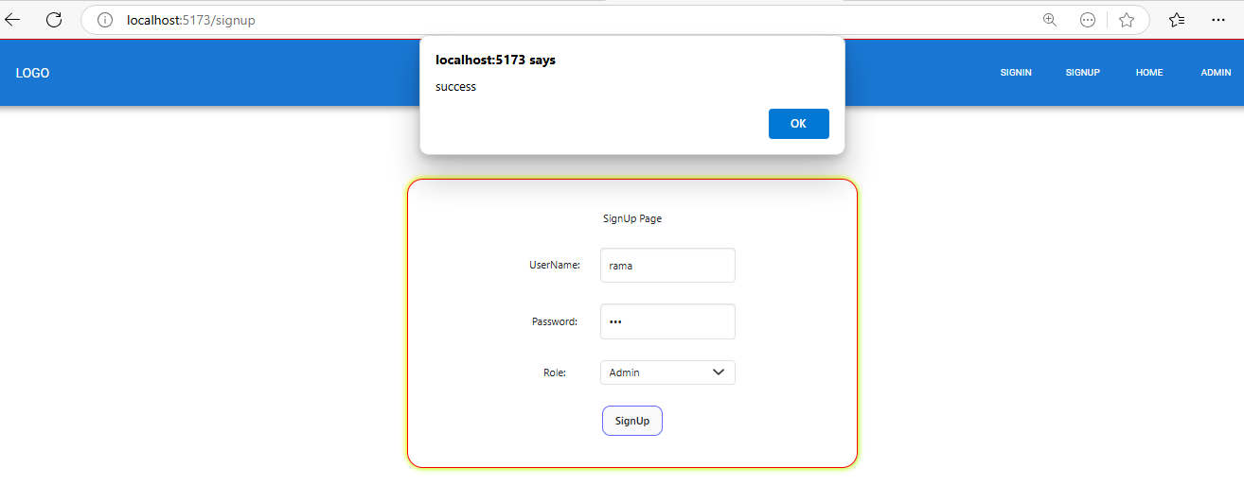

**SignIn (as Admin) Output**

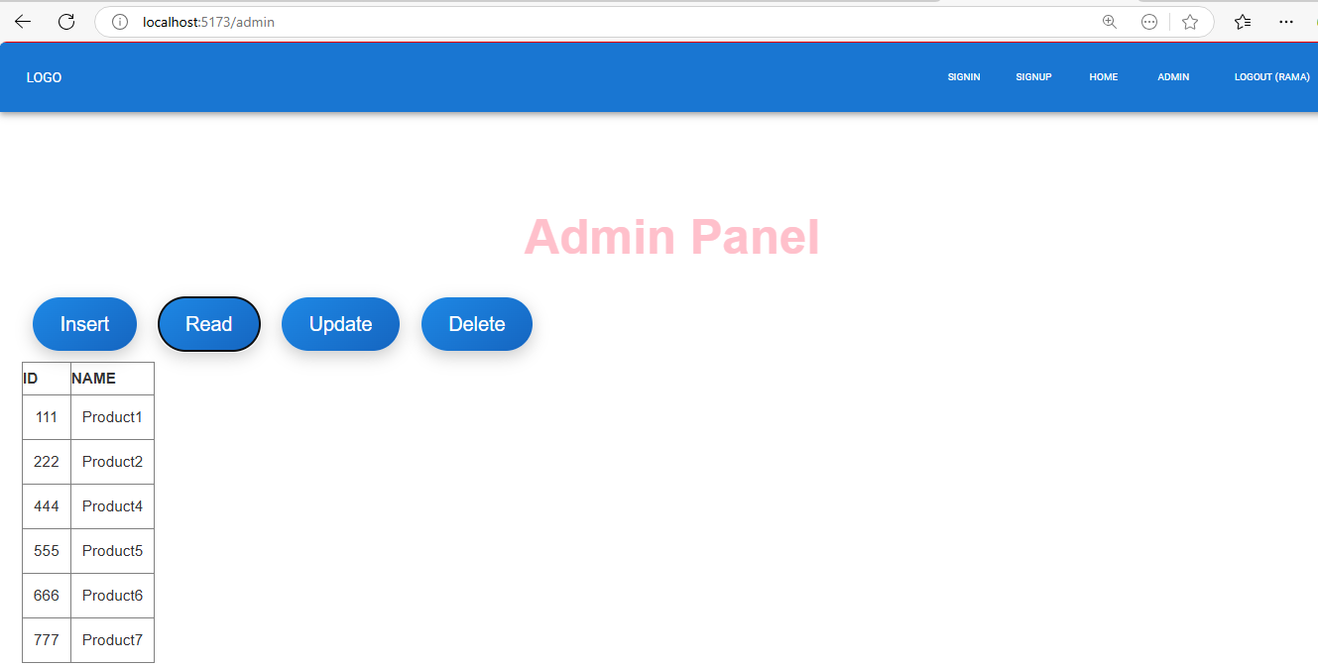

**SignIn (as User) Output**

